Name: ________________________

Dilation Homework

Determine whether the dilation from Figure A to Figure B is a reduction or an enlargement. Then find its scale factor.
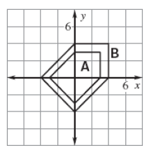
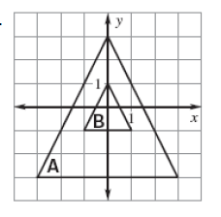
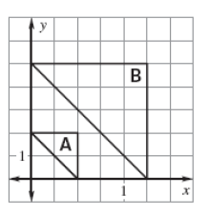
Ex. 1. 2.

________scale: ____ ________scale: ____ ________scale: ____

Point A is a vertex of a polygon. Point R is the image of A after the dilation. Find the scale factor of the dilation.

Ex. A (-2, -3) and R (-10, -15) 3. A (3, 4) and R (9, 12) 4. A (9, 12) and R (6, 8)

Draw a dilation of the figure using the given scale factor.

Ex. $1\frac{1}{2}$ 5. scale 2 6. Scale $\frac{1}{4}$
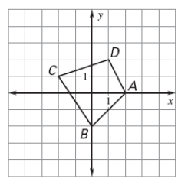
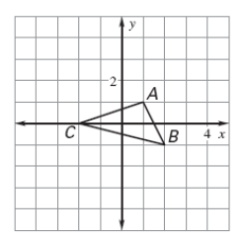
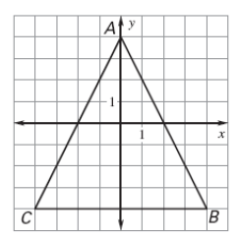

Determine scale dilation from Figure A to Figure B and then, find the values of the variables.
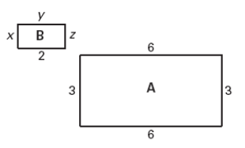
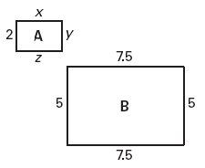
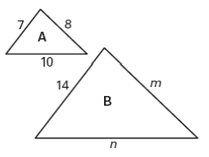
Ex. 7. 8.

Draw a dilation of the polygon with the given vertices using the given scale factor. Plot the ordered pairs on the coordinate plane AND the dilation.

9. A(-2, 1), B(-4, 1), C(-2, 4); scale 2 10. A(-5, 5), B(-5, 10), C(10, 0); scale $\frac{3}{5}$
