Name: ________________________

Graphing System of Equations Homework

Directions: Graph the following system of equations.

1. y = 2x - 4 2. y = 4x + 1 3. y = $-\frac{5}{3 }$x + 1
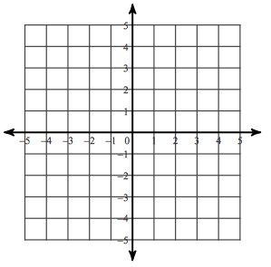
y = $\frac{1}{4 }$x + 3 y = x – 2 y = $-\frac{1}{3 }$x - 3
Solution:
Solution:
Solution:

4. y = $-\frac{1}{3 }$x + 2 5. y = 2x - 3 6. y = $-\frac{3}{2 }$x + 4
y = -2x - 3 y = -3x + 2 y = $\frac{3}{2 }$x – 2
Solution:
Solution:
Solution:

Write the equations in y-intercept (slope intercept) form and then graph to find the solutions.

7. -2x – y = 1 8. -2y – 5x = 2 9. x + y = 3
-6x + 3y = 3 2y - 5x = -4 8x + y = -4

Solution:
Solution:
Solution:

Solving Equations Homework

Solve for the variable in each equation.

1. -18 – 6m = 6(1 + 3m) 2. 2.3n + 4.98 = 3n + 2.6

3.-6.1p – 27.7 + 10.9p = 2.8p – 0.3 4. 6(6y + 6) – 5 = 1 + 6y

5. 10(v + 3) + 9v + 4 = 3 + v – 5 6. -16 + 5n = -7(-6 + 9n) + 3

7. -4x + 2(5x – 6) = -3x – 39 8. -10y + 3(8 + 8y) = -6(y – 4)

