Name ______________________

Linear Equation Homework

1. A 50-gallon rain barrel is filled to capacity. It drains at a rate of 10 gallons per minute. Write an equation to show how much water is in the barrel after x minutes of draining. Then make a graph for this function.

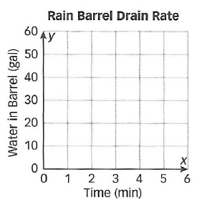

2. An amusement park charges $8 for admission and $2 for each ride. Write an equation for the function that relates the total cost to the number of rides.

3. Write an equation for the table of values.
x | 1 | 2 | 3 | 4 | 5 | 6
y | 4 | 7 | 10 | 13 | 16 | 19

4. A fitness club charges its members a sign-up fee of $50 and a weekly fee of $7.50. Write an equation to show the cost of the membership at the fitness club x weeks.

5. Danielle is filling her pool. The pool has 3,000 gallons of water in it now. The water hose that Danielle uses puts 500 gallons per hour into the pool. Write an equation for the number of gallons y of water in the pool after x hours.
1
6. Bailey Taxi Service charges a pick-up fee of $5.00 plus a charge of $1.80 for each mile driven. Another taxi service Logan’s Taxi Service charges a pick-up fee of $4 plus a charge of $1.75 per mile driven. Write equations for these functions, and identify the slope and the y-intercept for each.

Bailey Taxi Service | Logan’s Taxi Service
Slope: | Slope:
y-intercept: | y-intercept:
Equation: | Equation:

7. The Peach Festival charges $12 for admission and $2.25 for each pound of peaches picked. Write an equation for the total cost y if you pick x pounds of peaches. Write an equation and use your equation to find the total cost of attending the festival and picking 5 pounds of peaches.

8. Christian wants to buy a new wireless phone for $200. Two stores offer different payment options. Which plan has a greater initial value? Which plan has a greater rate of change?

Store A Payment Plan
Store B Payment Plan
Pay $50 at the time of purchase. Pay $20 per month until the phone is paid for.

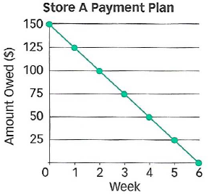

Write the equation for both payment plans.
Store A: Store B:
2

