Name: __________________________________

Reflection Homework

Reflect according to the given situation
1. Reflect trapezoid WXYZ with vertices 2. Reflect rhombus QRST with vertices
W(2, 4), X(2, -2), Y(4, -1), Z(4, 3) Q(-1, 5), R(-4, 3), S(-1, 1), T(2, 3)
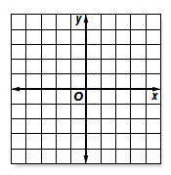
over the y-axis across the x-axis

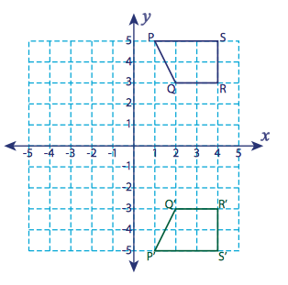
Describe the reflection:
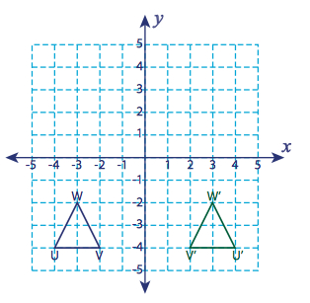
3. 4.

Write the coordinates obtained after the given reflection:

5. P(-8, 5), Q(-5, 5), R(-5, 8), S(-8, 8) 6. S(-7, -5), T(-7, -8), U(-6, -8), V(-6, -5)
Reflection across the y-axis Reflection across the x-axis
P´: _____, Q´: _____ S´: _____, T´: _____

R´: _____, S´: _____ U´: _____, V´: _____

