Name: _________________________________________ Date: ____________________

Scatter Plot Quiz Homework Review

1. Does the following scatter plot show 2. Does the following scatter plot show
a relationship? If so, what kind? a relationship? If so, what kind?
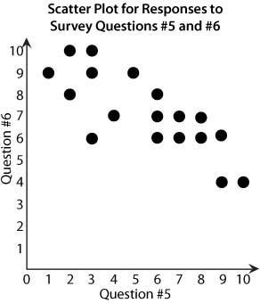
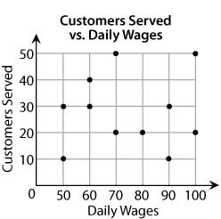

3. Does the following scatter plot show 4. Does the following scatter plot show
a relationship? If so, what kind? a relationship? If so, what kind?

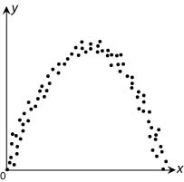
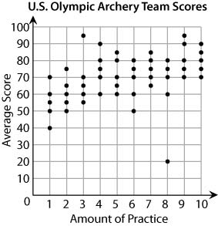

5. Identify any clusters with a circle and 6. Identify any clusters with a circle and
and any outliers with a square. and any outliers with a square.
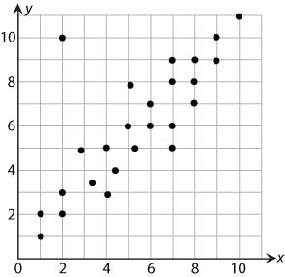
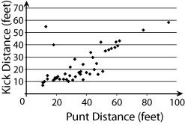

7. Draw the line of best fit. 8. Draw the line of best fit.

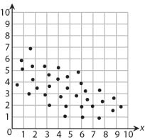
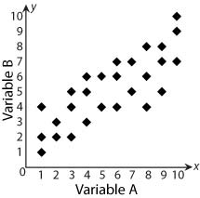

9. Write the equation for the following line 10. Write the equation for the following line
of best fit. of best fit.

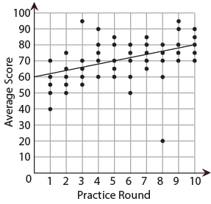
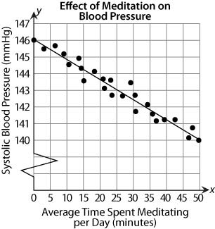

11. Using your equation from #9, if you practice for 14 rounds what would your average score be?

