Name: __________________________________________

Solving Systems of Equations
A. Graphing:
1. Write equations in _________________.
2. Graph both equations.
3. ___________ is where the two lines intersect.

Example 1: y = x + 3 Example 2: y = 4x - 11
y = 2x + 5 y = -3x + 3
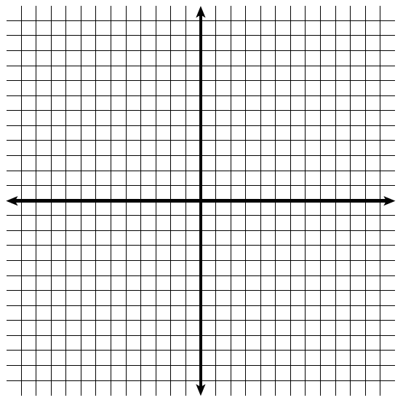

Solution: __________ Solution: __________

Example 3: y = -x + 4 Example 4: y = ½x + 2
2y + 2x = 8 2y = x - 6

Solution: __________ Solution: __________
B. Transitive:
1. For equations already in _________________.
2. Set equations up ________ to each other.
3. Solve for ________.
4. Plug the value of x into one of the _______________ to solve for y.

Example 1: y = x + 4 Example 2: y = -3x + 2
y = -x – 4 y = -x - 8

If x = _____ then y = _____ If x = _____ then y = _____

Solution: _____________ Solution: _____________

Example 3: y = 2x + 9 Example 4: y = 3x + 5
y = -8 + 2x y = 3x - 10

If x = _____ then y = _____ If x = _____ then y = _____

Solution: _____________ Solution: _____________
C. Substitution:
1. Set up one equation in ___________.
2. _______________ the expression from Step 1 into the other equation and
solve for the other variable.
3. Substitute the value from step 2 into either ________________ and solve for the ___________________.

Example 1: -3x + y = 1 Example 2: 3x + y = 8
4x + y = 8 6x + 2y = 16

If x = _____ then y = _____ If x = _____ then y = _____

Solution: _____________ Solution: _____________

Example 3: 2x – 3y = -24 Example 4: 3x + y = 11
x + 6y = 18 -2x + y = 1

If x = _____ then y = _____ If x = _____ then y = _____

Solution: _____________ Solution: _____________
D. Elimination:
1. _______________________ the equations to eliminate one variable.
2. ____________ the resulting equation for the other variable.
3. Substitute the value into either _____________________ to find the value of the _______________ variable.
Adding:
Example 1: 2x – 3y = 12 Example 2: 2x + 2y = -2
x + 3y = 6 3x – 2y = 12

If x = _____ then y = _____ If x = _____ then y = _____

Solution: _____________ Solution: _____________

Subtracting:
Example 3: 3x + 3y = 6 Example 4: 6x – 3y = 6
3x - y = -6 6x + 8y = -16

If x = _____ then y = _____ If x = _____ then y = _____

Solution: _____________ Solution: _____________

