Name: __________________________ Parent Signature: _________________

Transformation and Equations Review
1. Rotate the following quadrilateral 90˚ counterclockwise. Then reflect it across the y-axis. What are the new coordinates of the vertices of the new quadrilateral.  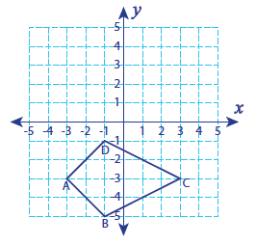  A: __________ B: __________  C: __________ D: __________ | 2. Reflect the following trapezoid over the x-axis. Then rotate the resulting image 180˚.  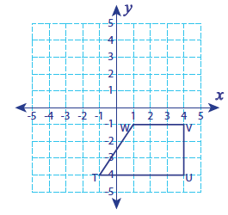  T: __________ U: __________  V: __________ W: __________
3. Translate the following with the rule: (x - 4, y – 2), then reflect over the  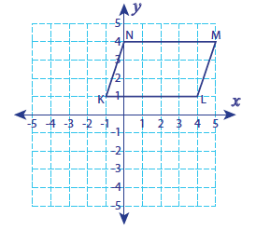  y-axis.  K: __________ L: __________  M: __________ N: _________ | 4. Translate:  E(2, 0), F(5, 1), G(4, 2), H(2, 2)  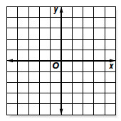  7 units left and 3 units up; then rotate 90˚ clockwise.  E: __________ F: __________  G: __________ H: _________
6. Write the equations for: the difference of two numbers is 3. Their sum is 13.

7. Quadrilateral with the following vertices:
P(–4, 1), Q(–2, 1), R(–2, 3), S(–3, 3) is dilated by a factor of 3 with the origin as the center of dilation. What are the new coordinate points?

P: _________ Q: _________ R: _________ S: _________
8. Meredith’s school is selling tickets to the spring musical. On the first day of ticket sales the school sold 3 senior citizen tickets and 9 child tickets for a total of $75. The school took in $67 on the second day by selling 8 senior citizen tickets and 5 child tickets. Write the system of equations that you could use to determine the price of one senior citizen ticket and one child ticket?

9. A large pizza at Palanzio’s Pizzeria costs $6.80 plus $0.90 for each topping. The cost of a large cheese pizza at Guido’s Pizza is $7.30 plus $0.65 for each topping. Write the system of equations you could use to find how many toppings need to be added to a large chesse pizza from Palanzio’s Pizzeria and Guido’s Pizza in order for the pizzas to cost the same.

____10. Which series of transformations shows that figures 1 and 2 are similar?

A. a 180° rotation of figure 1 about the origin, then
a dilation with scale factor $\frac{3}{4}$ centered at (1,–3)
B. a 90° clockwise rotation of figure 1 about the
origin, then a dilation with scale factor $\frac{3}{4}$ centered at (4,–3)
C. a 180° rotation of figure 1 about the origin, then
a dilation with scale factor $\frac{3}{4}$ centered at (4,–3)
D. a 90° clockwise rotation of figure 1 about the
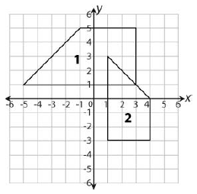
origin, then a dilation with scale factor $\frac{3}{4}$ centered at (1,–3)
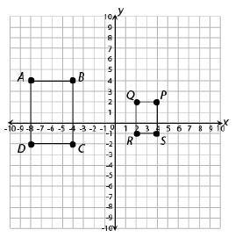
____11. Rectangle ABCD undergoes a series of transformations to create similar rectangle PQRS as shown below.
Which series of transformations could rectangle ABCD have undergone to result in rectangle PQRS ?
A. a dilation with a scale factor of $\frac{1}{2}$ and a reflection
across the x-axis
B. a dilation with a scale factor of $\frac{1}{2}$ and a reflection
across the y-axis
C. a dilation with a scale factor of 2 and a reflection across the x-axis
D. a dilation with a scale factor of 2 and a reflection across the y-axis

