Name: ____________________

Translation Homework

Translate the shapes using the given translation:

Rule: Rule: Rule:
1. 5 units left ( ) 2. 2 units right ( ) 3. 4 units right ( )
3 units up ( ) 7 units down ( ) 5 units down ( )

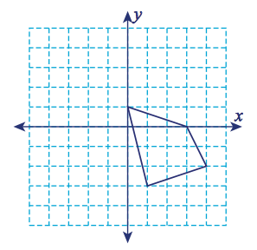
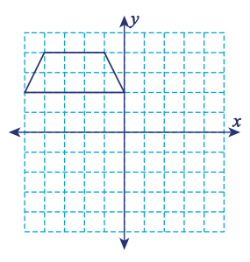
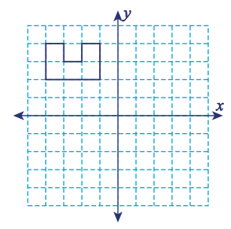

Write the rule for to describe the translation.
4. 5. 6.

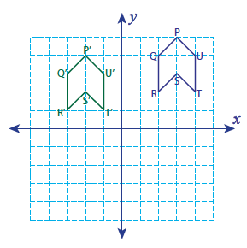
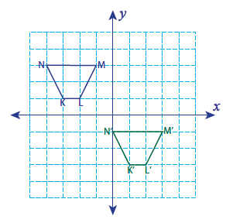
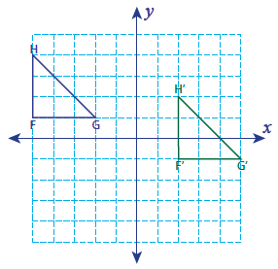

Write the rule and the coordinates obtained after the given translation.

7. A(-5, 3), B(-3, 3), C(-2, 5), D (-5, 4) 8. P(2, 1), Q(4, 1), R(5, 3), S(2, 3)
8 units down and 7 units right 2 units up and 5 units left

Rule: __________ __________ Rule: __________ __________

A´: _____, B´: ______ P´: _____, Q´: _____
C´: _____, D´: ______ R´: _____, S´: _____

