Name: _______________________ Monday 2/6/17

Transversals Homework

1. Find the value of x.  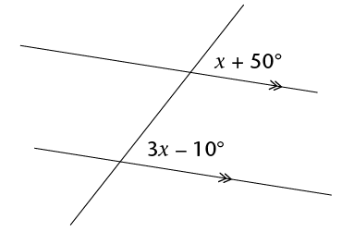 | 2. Calculate the value of x.  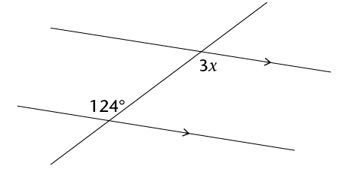
3. Find the measure of angles 1 and 7.  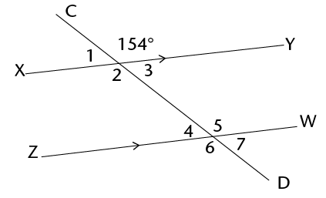 | 4. Find the value of x.  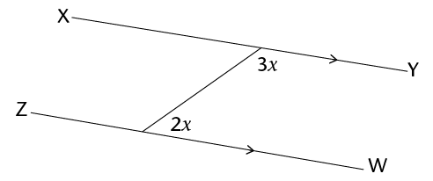
5. m$∠$ACH = x + 24˚, m$∠$DCH = x – 8˚  Find the measures of the two angles.  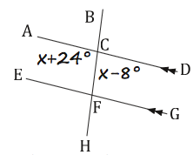 | 6. m$∠$ACB = 2x - 45˚, m$∠$HFG = x + 23˚  Find the measures of the two angles.  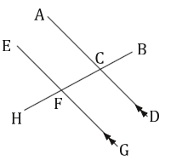

Tuesday 2/7/17

1. Calculate the m$∠$CEP  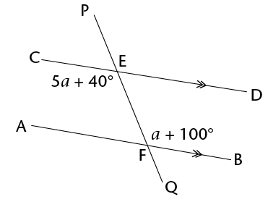 | 2. Calculate a, b, c, and d.  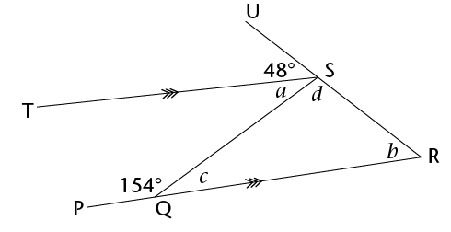
3. Calculate x, y, and z  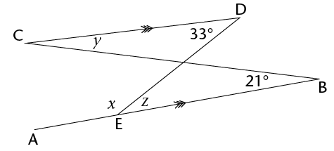 | 4. Calculate the m$∠$T and m$∠$R.  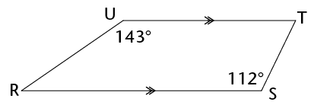
5. Find the value of x.  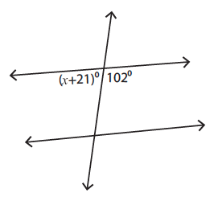 | 6. Find the value of x.  