Name: _______________________ Date: __________

Writing and Solving Equations Quiz Review Homework

Directions: Show work and then write your answer on the line provided.

___1. You have $1.85 in nickels and dimes. You have 5 more dimes than nickels. How many of each type of coin do you have?

a. n + d = 1.85 b. .05n + .10d = 1.85
d + 5 = n n + 5 = d

For questions 2 and 3
Two bowling alleys are comparing their prices. Bowl More charges $2 per game plus a one-time charge of $4 for shoe rental. Straight Strokes bowling charges $3 per game plus a one-time charge of $2 for shoe rental.

2. Write the two equations which represents how much each bowling alley charges

Bowl More:

Straight Strokes:

___3. The total cost will be less at Bowl More if you bowl how many games?

a. 1 b. 2 c. 3 d. 4

___4. Which system of linear equations, when graphed has lines that intersect at (5, 10)?

a. 2y – x = 0 b. y = 2x c. x – y = -5 d. y – x = 5
x + y = 15 x + y = 15 y = 5x + 10 y = 5x

____5. Which system of equations intersects at (-1, 4)

a. 2x + 4y = 9 b. y + 2x = 6 c. y – 2x = 6 d. x + 4y = 15
x + 2y = 15 x + 4y = 15 x + 4y = 15 4x – y = 2

___6. The x-coordinate of the intersection of the graphs of the system of equations shown below is 3. What is the y-coordinate of the intersection?

2x + y = 3
-x + 3y = -12

a. 0 b. -5 c. 3 d. -3
____7. A system of linear equations is graphed on this coordinate grid.
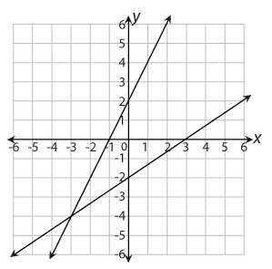

What is the solution to the system of equations?

a. (-2, 2)
b. (-3, -4)
c. (-1, -2)
d. (-1, 3)

___8. What is the solution to the system of equations below?

8x – 3y = 5
8x – 3y = 11

a. (0, 0) b. (0, 6) c. infinite solutions d. no solution

____9. The point (-2, 3) is the solution to a system of two linear equations. Which of the following can be one of the equations?

a. y = -2x + 3 b. y = 3x – 2 c. y = -x + 1 d. y = x - 1

____10. Solve the system algebraically: y = 2x + 4
y = $\frac{1}{2}$x - 2

____11. Solve the system algebraically: y = x + 4
5x + 2y = 1

____12. Solve the system algebraically: -2x + 5y = 10
-4x + 10y = 20

____13. Solve the system algebraically: 3x + y = 13
6x + 2y = 26

